**PRACTICAL 3**

**AIM: CRUD using MongoDB.**

**Create new Database and new Collection.**

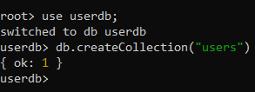

**Create Operations.**

**insertOne()**

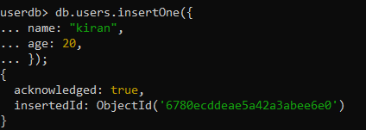

**insertMany()**

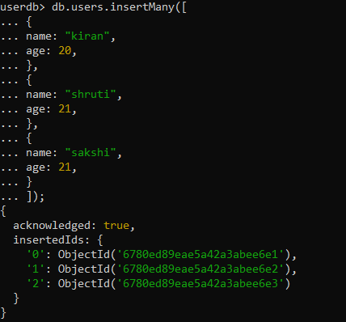

**Read Operations.**

**find()**

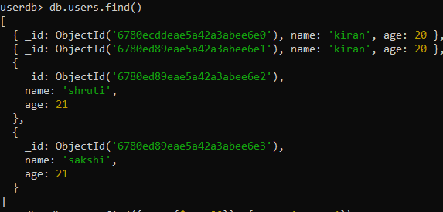

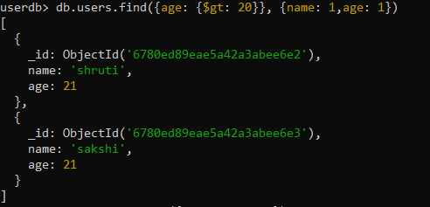

**findOne()**



**Update Operations.**

**updateOne()**

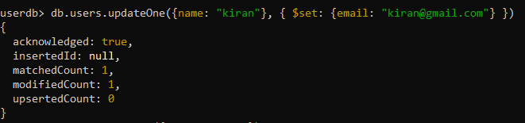

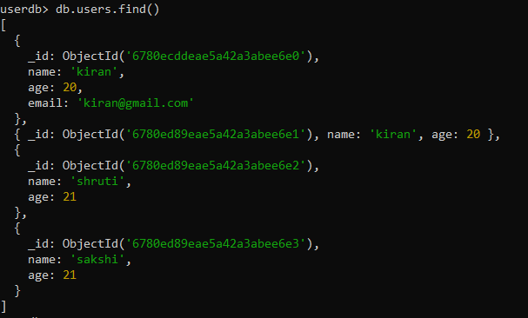

**updateMany()**

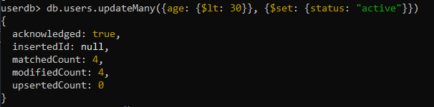

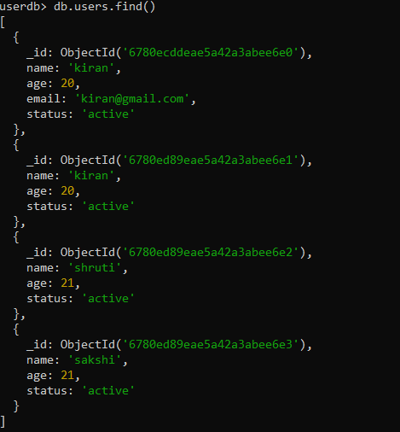

**find().pretty()**

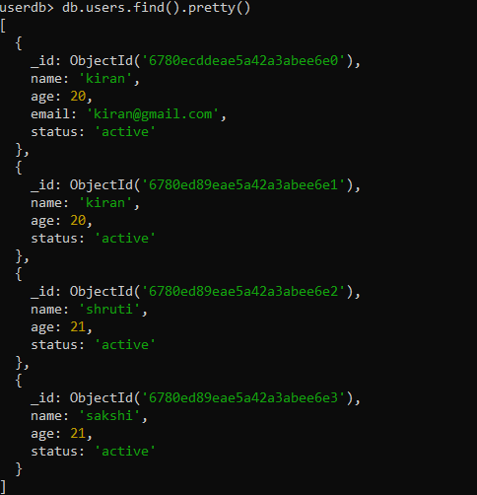

**Delete Operations.**

**deleteOne()**

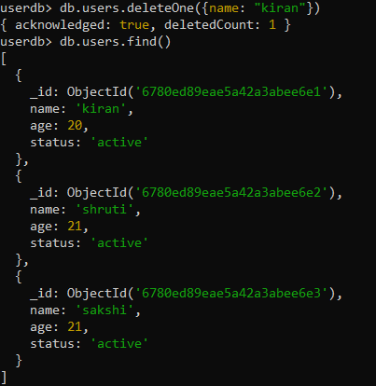

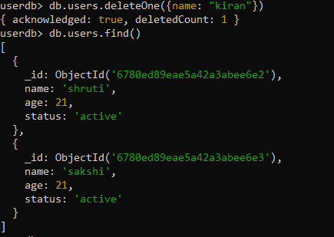

**deleteMany()**

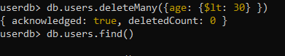

**drop()**

